**Project Design Phase-II**

**Technology Stack (Architecture & Stack)**

|  |  |
| --- | --- |
| Date | 03 October 2022 |
| Team ID | PNT2022TMID33418 |
| Project Name | Project – A Novel Handwritten method for digit recognition |
| Maximum Marks | 4 Marks |

**Technical Architecture:**

The Deliverable shall include the architectural diagram as below and the information as per the table1 & table 2

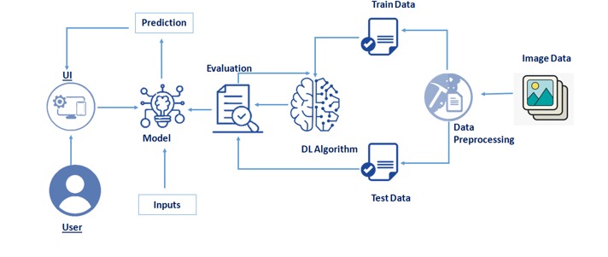

Guidelines:

1. It Process the images to identify digits
2. It contains the MNIST Dataset identify the digits
3. Indicate external interfaces
4. It contains the IBM DB2 Cloud

**Table-1 : Components & Technologies:**

|  |  |  |  |
| --- | --- | --- | --- |
| **S. No** | **Component** | **Description** | **Technology** |
|  | User Interface | How user interacts with application e.g.  Web UI, Mobile App, Chatbot etc. | HTML, CSS, JavaScript / Angular Js / React Js etc. |
|  | Application Logic-1 | Logic for a process in the application for application access | Java / Python |
|  | Database | Data Type, Configurations etc. | MySQL, NoSQL, etc. |
|  | Dataset | Dataset for Digit Recognition | MNIST Dataset |
|  | Deep Learning Model | Purpose of Deep Learning Model | Digit Recognition Model |

**Table-2: Application Characteristics:**

| **S.No** | **Characteristics** | **Description** | **Technology** |
| --- | --- | --- | --- |
|  | Open-Source Frameworks | List the open-source frameworks used | Technology of Opensource framework |
|  | Security Implementations | The model is secured by Login Id and Password | It should be encrypted and decrypted in database |
|  | Scalable Architecture | It should be scalable when more number of users uses the application | Technology used |
|  | Availability | It should be available in both online and offline mode | Technology used |
|  | Performance | It should be in good performance because of the architecture | Technology used |